**Little Bit Advance Labs**

**Part 1: EC2 with ELB and ASG**

**Objective**: Learn how to create a scalable and highly available web application environment using Amazon EC2 instances, ELB, and ASG.

1. **Launch EC2 Instances:**
2. Creating 2 security group http and ssh.

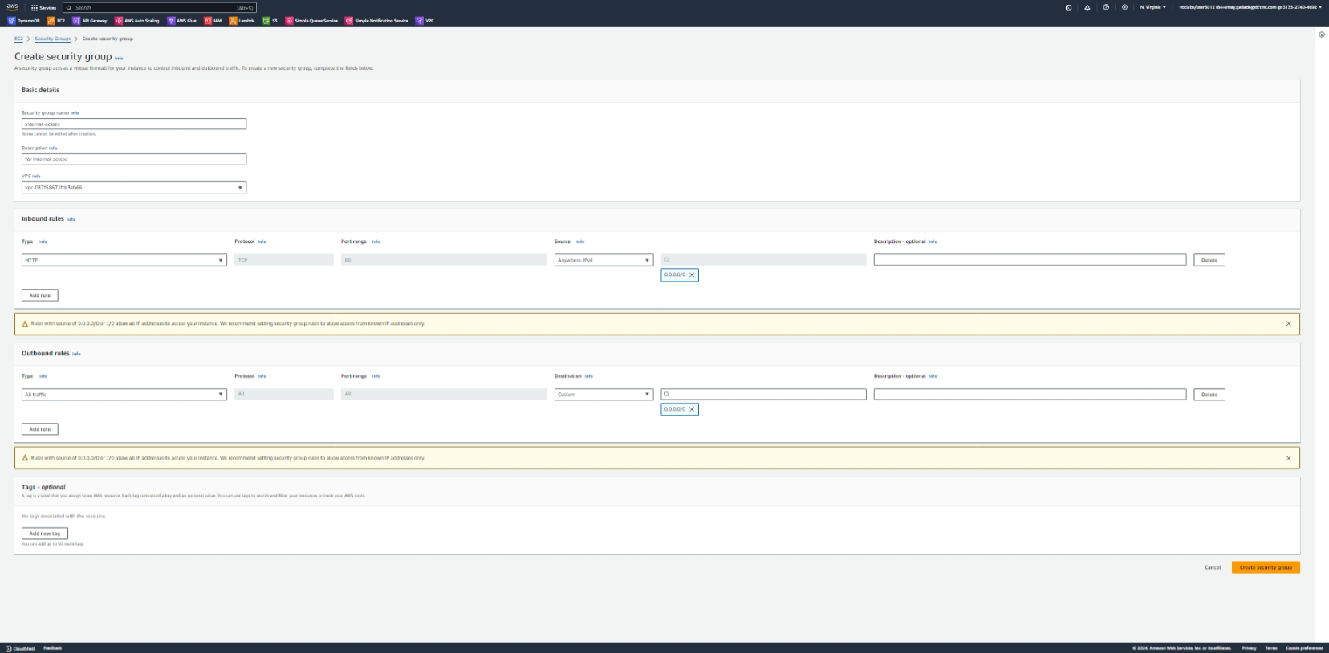

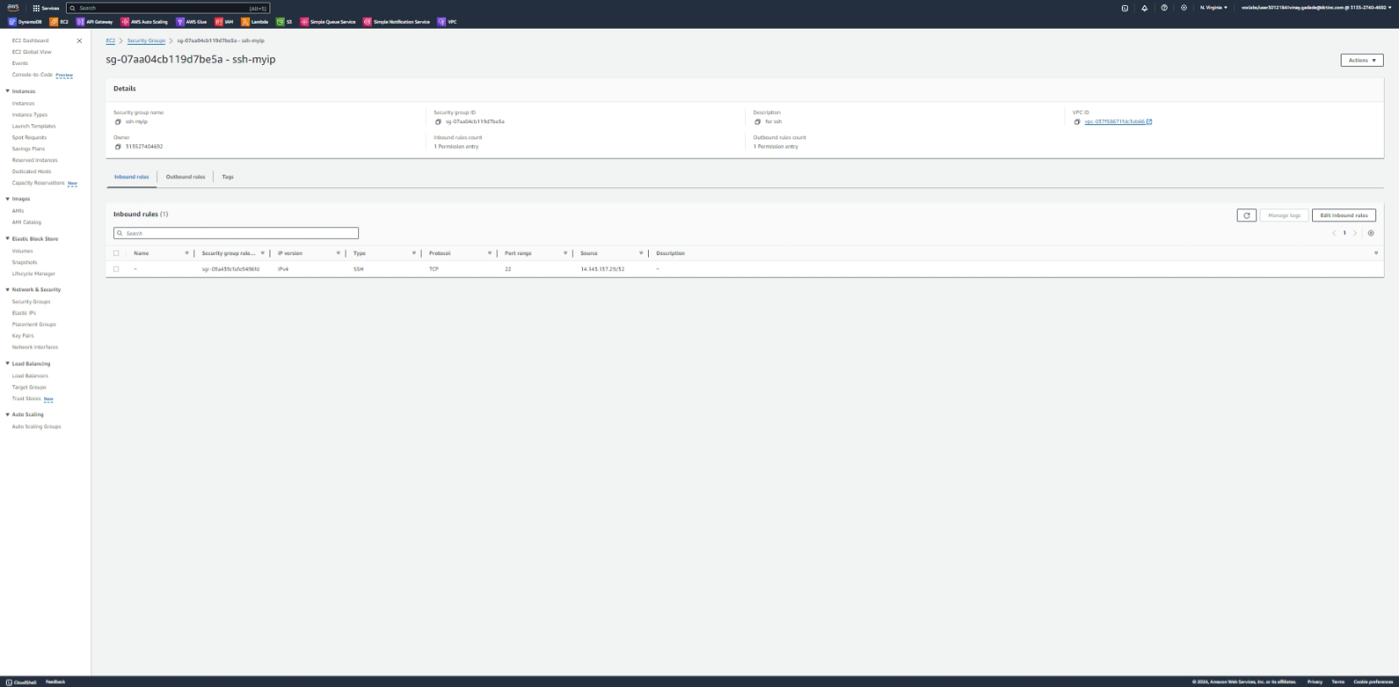

1. b) Go to the EC2 dashboard in the AWS Management Console. Click on "Launch Instance" and choose an Amazon Machine Image (AMI) for your instances (e.g., Amazon Linux).
2. Select an instance type, configure instance details, add storage, configure security groups (allow HTTP and HTTPS traffic), and review the instance launch.

Repeat these steps to launch at least two EC2 instances

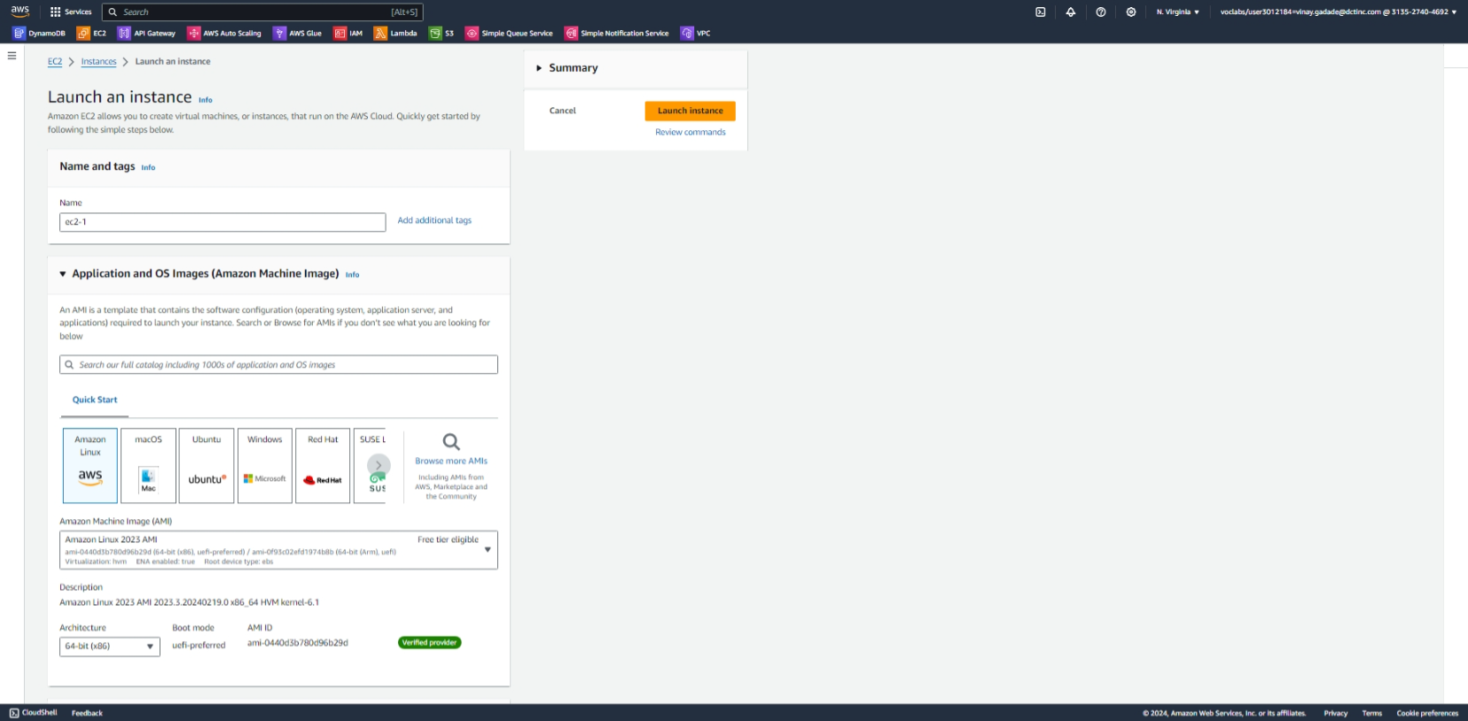

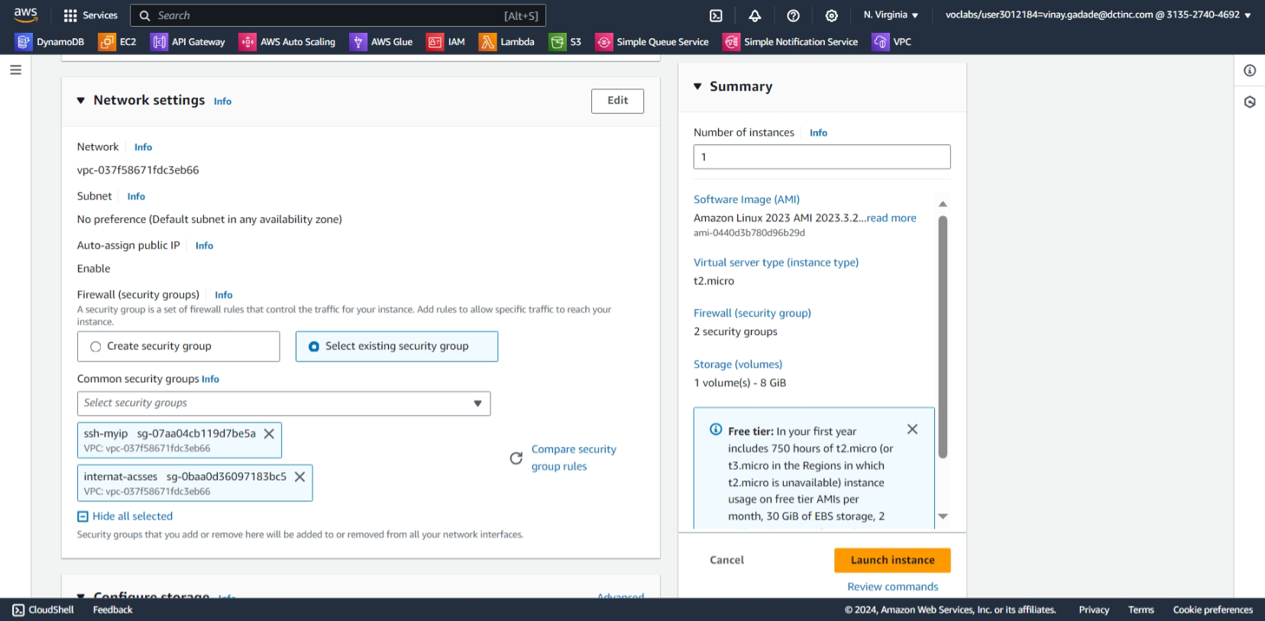

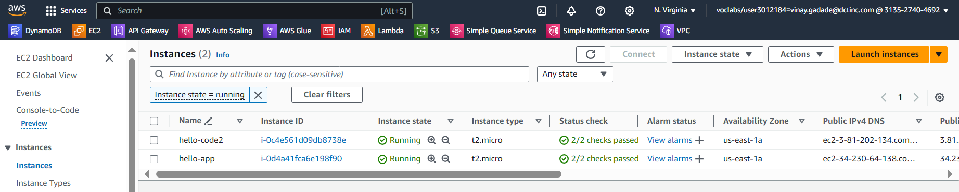

Testing creted website hello world , same for both instances

1. **Verify instances is running or not using windows Powershell**
   1. **Command used**
      1. **ssh -i C:\Users\Vinay.Gadade\Downloads\ddm.pem ec2-user@34.230.64.138**
      2. sudo su  
         yum update -y  
         yum install httpd
      3. systemctl start httpd  
         systemctl enable httpd
      4. chown -R $USER /var/www/html
      5. echo "<h1>Hello World</h1>" > /var/www/html/index.html
2. **Now open id address for Hello World webpage**

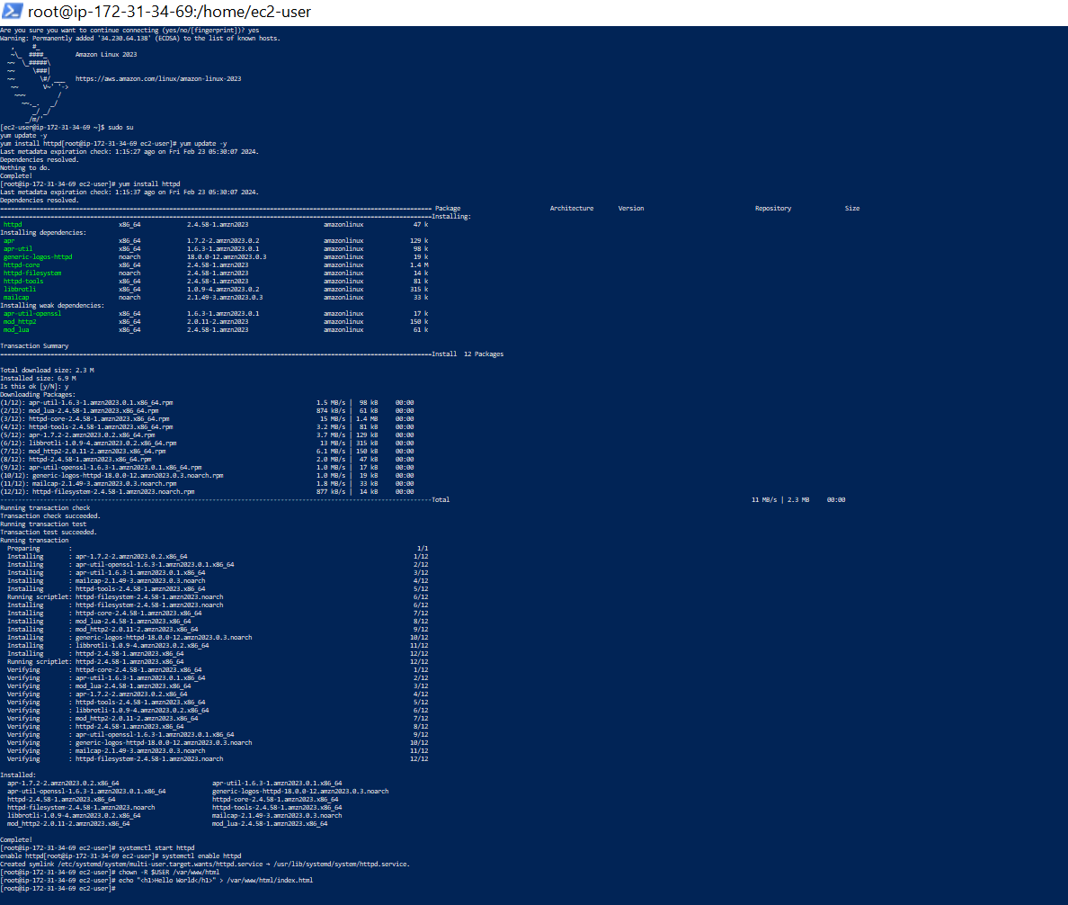

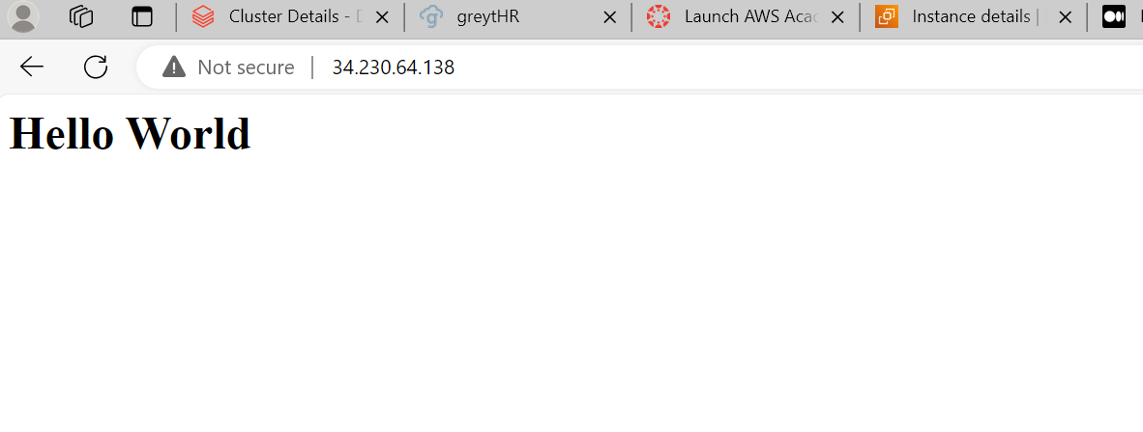

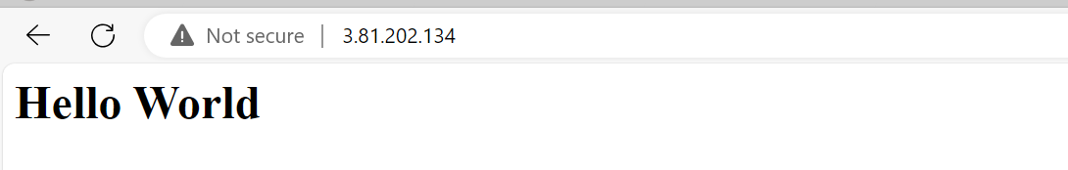

Creating target group

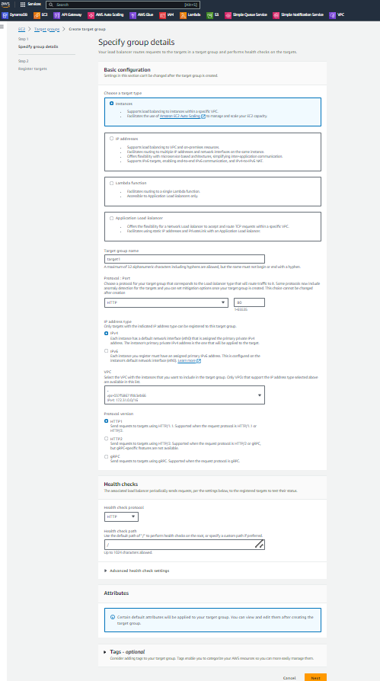



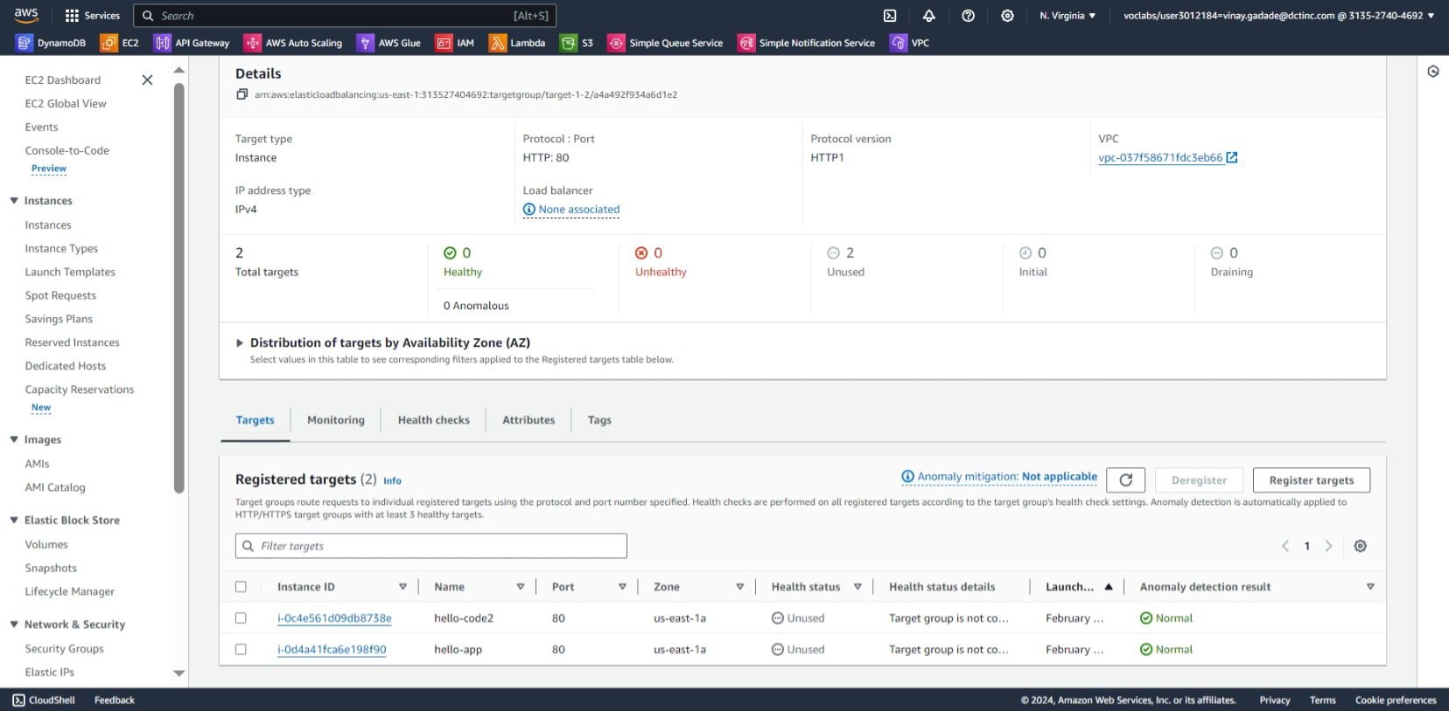

1. **Configure Load Balancer:**
2. Go to the EC2 dashboard and click on "Load Balancers" under the "Load Balancing" section.
3. Click on "Create Load Balancer" and select "Application Load Balancer".
4. Configure the load balancer settings, including name, scheme (internet-facing), listeners (HTTP and/or HTTPS), security settings, and routing.
5. Select the VPC and availability zones where your EC2 instances are located.
6. Configure the security groups to allow traffic from the internet to the load balancer.
7. Review and create the load balancer.

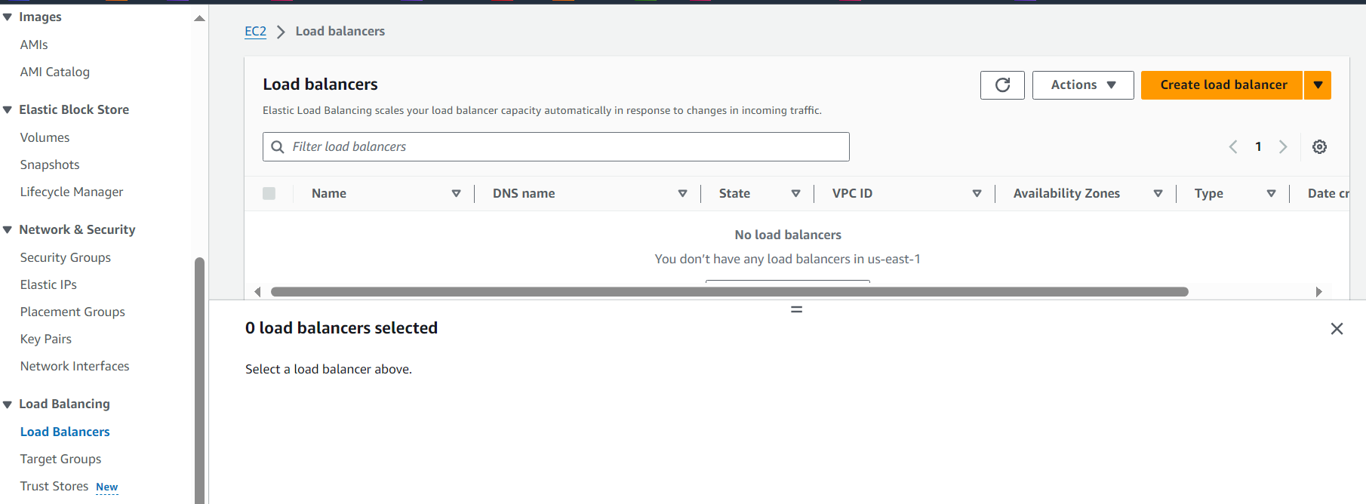

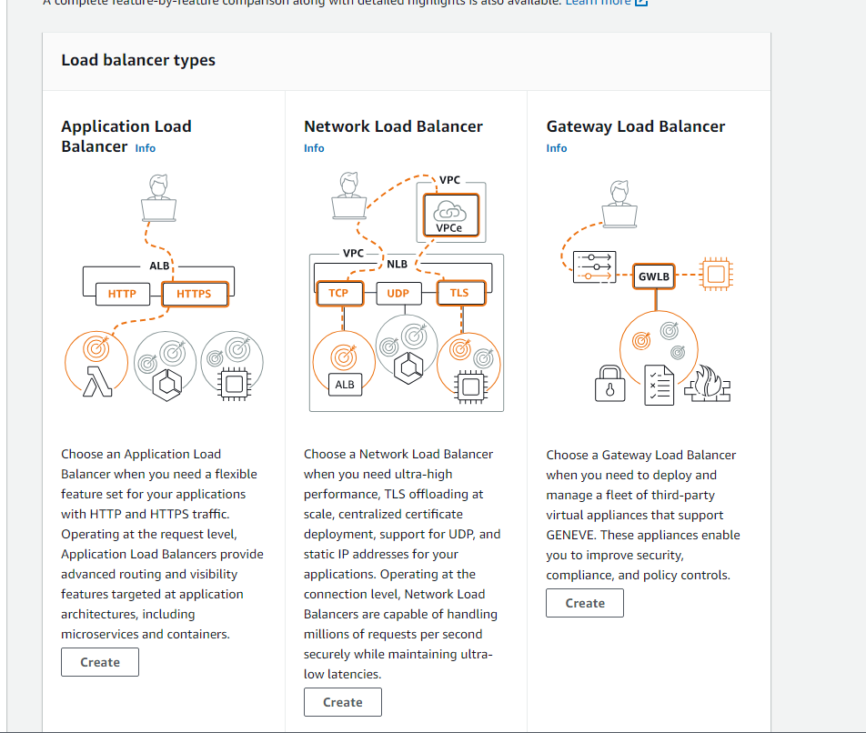

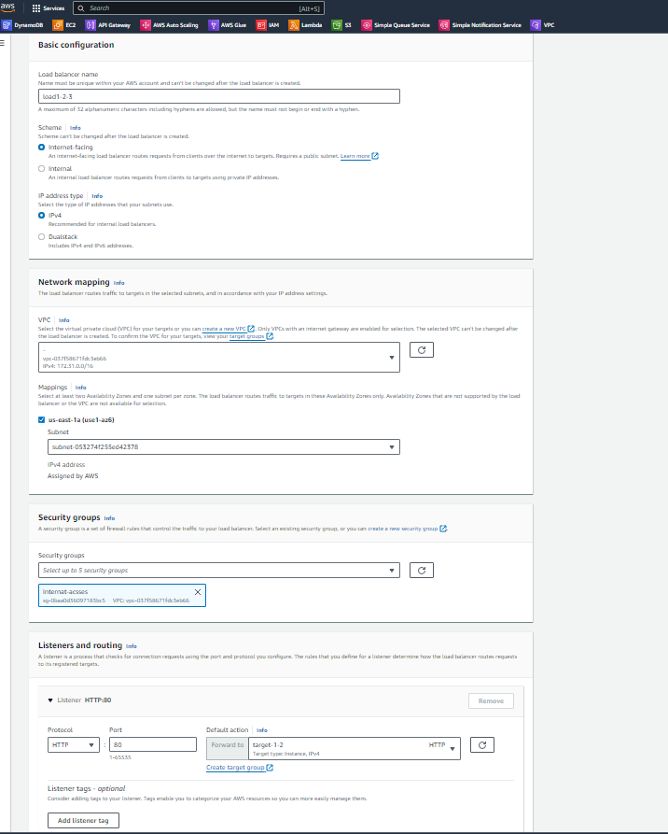

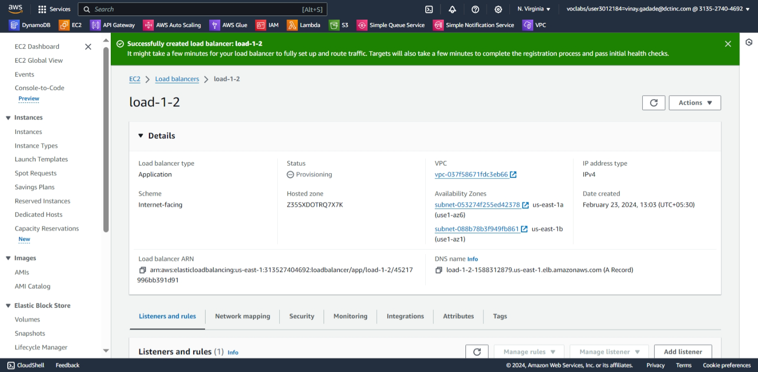

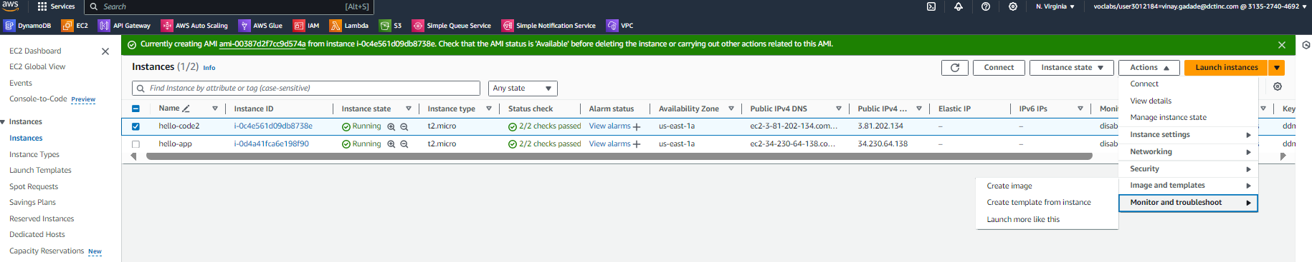

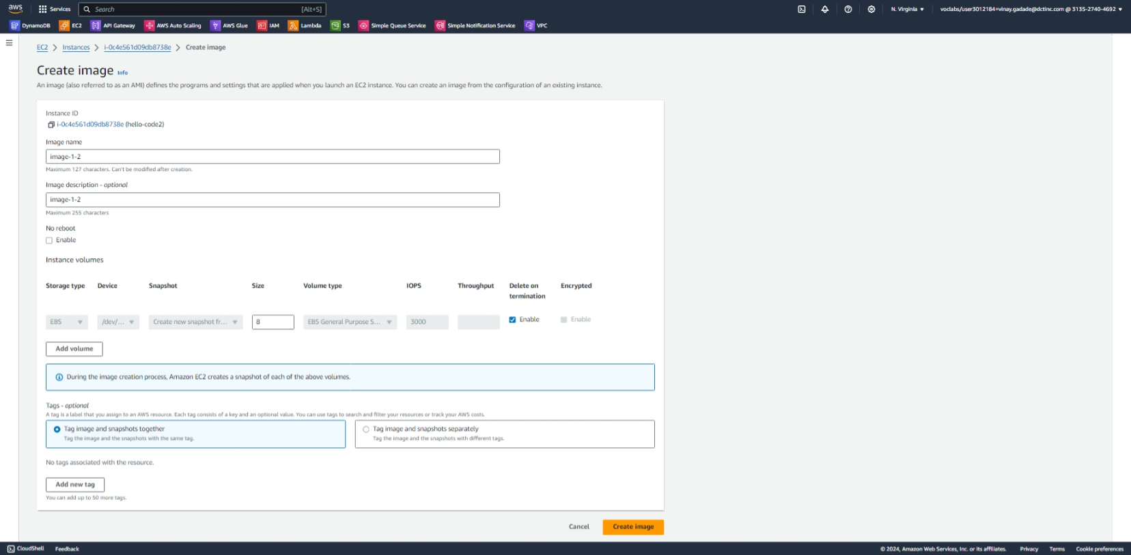

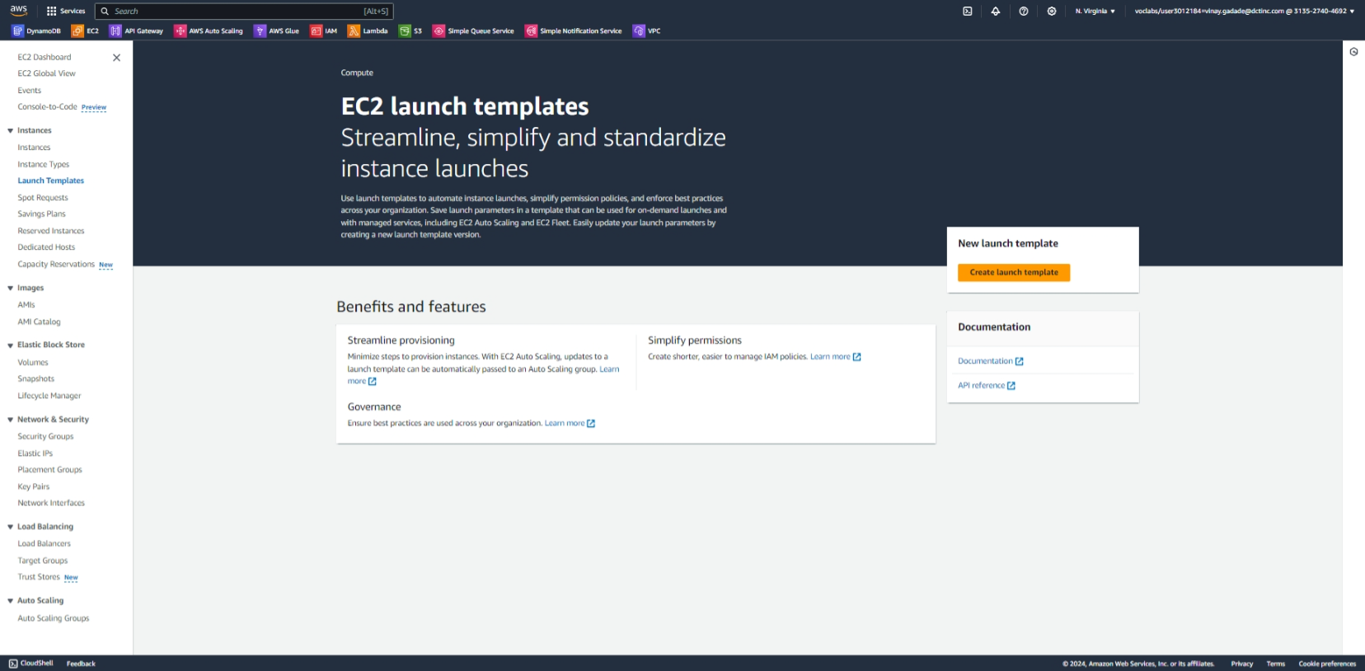

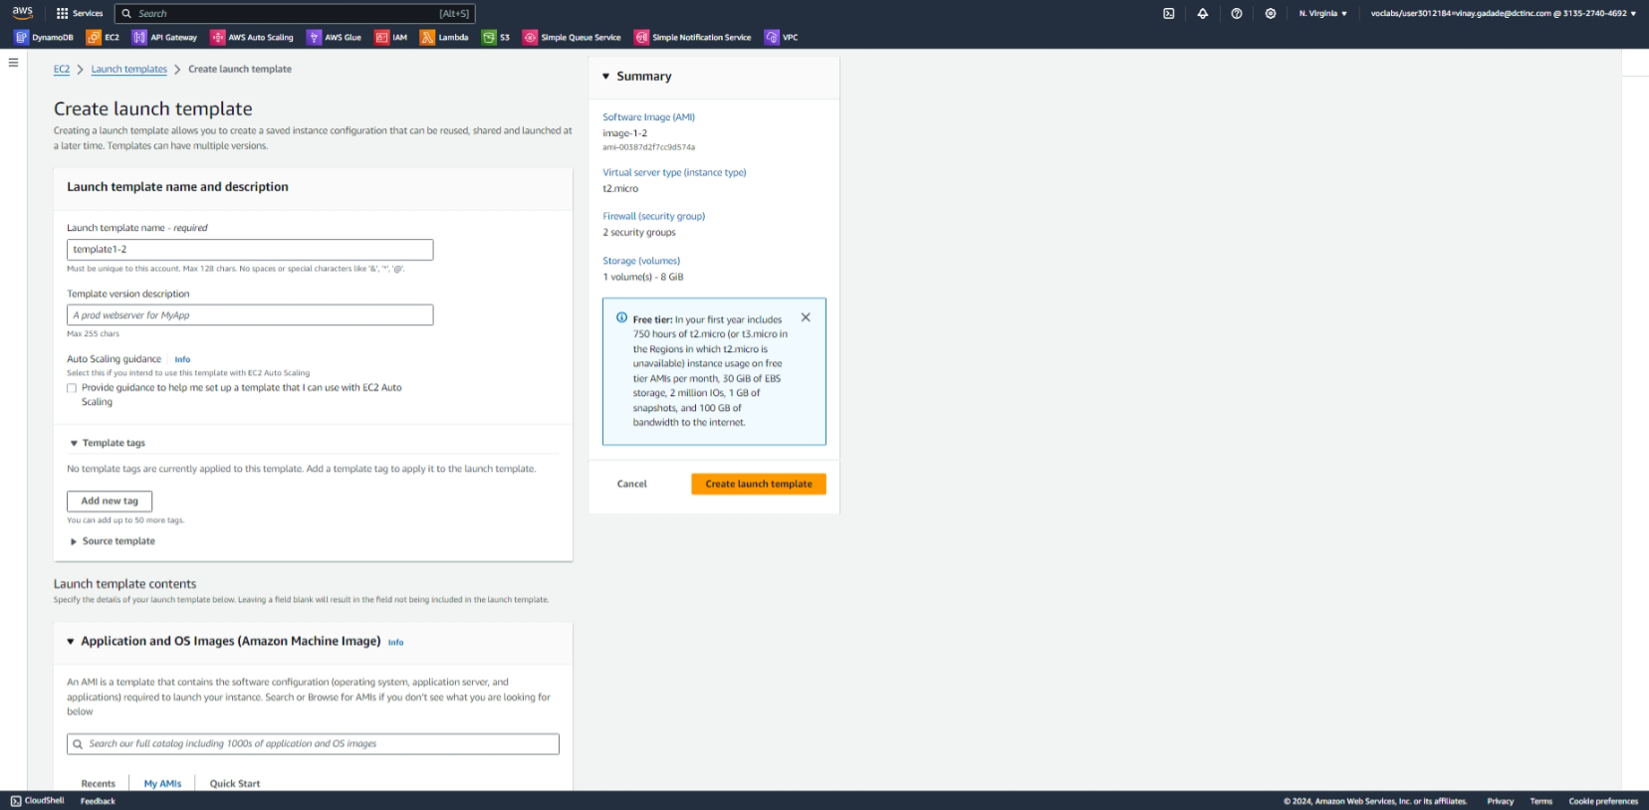

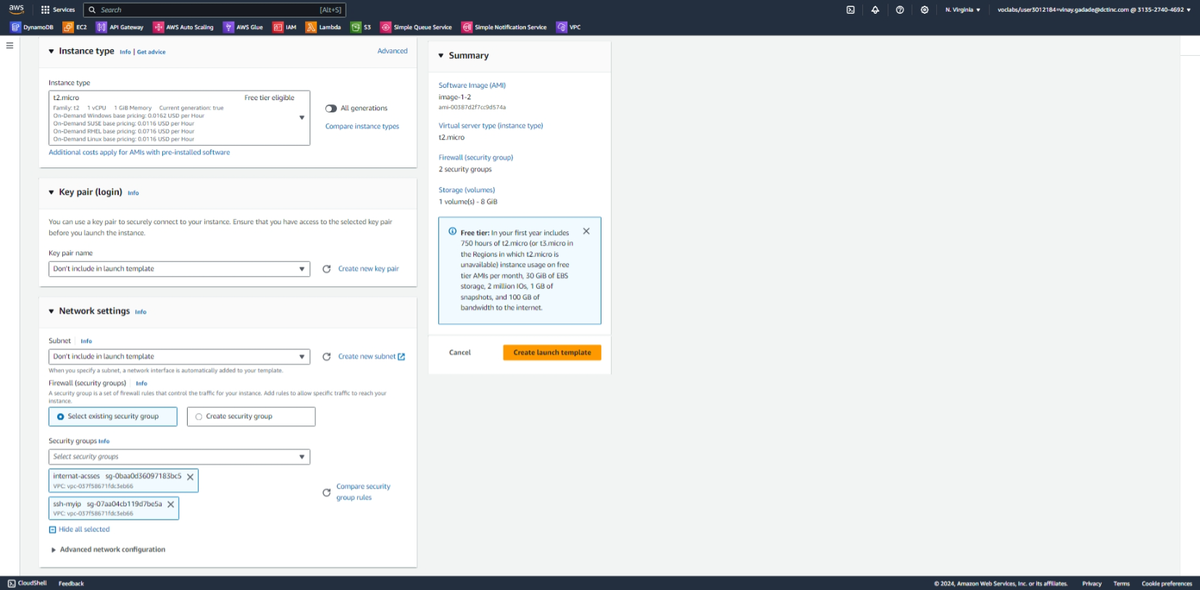

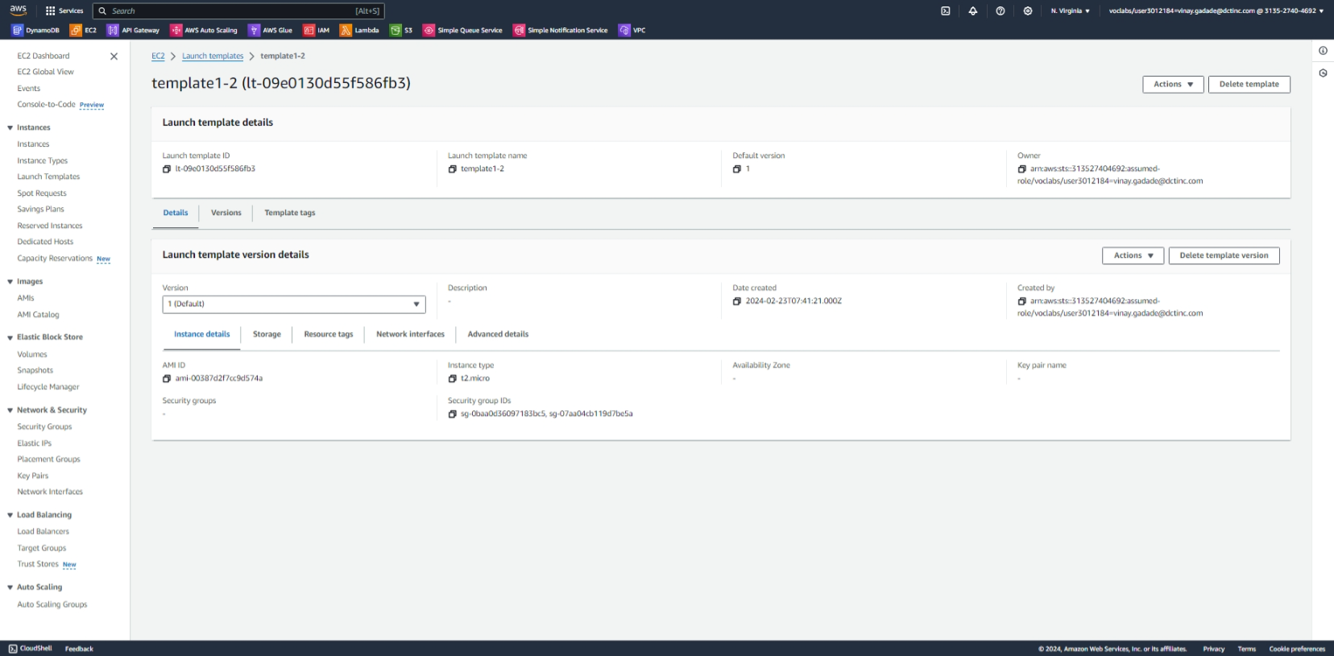

Auto scaling

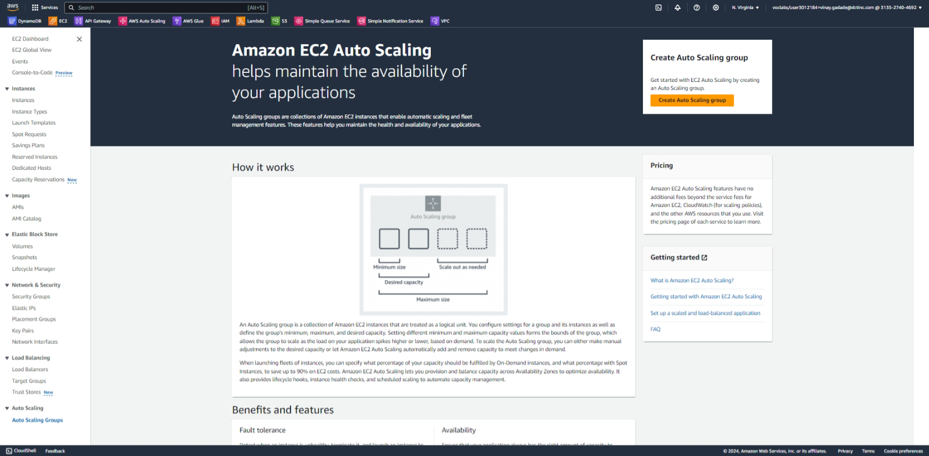

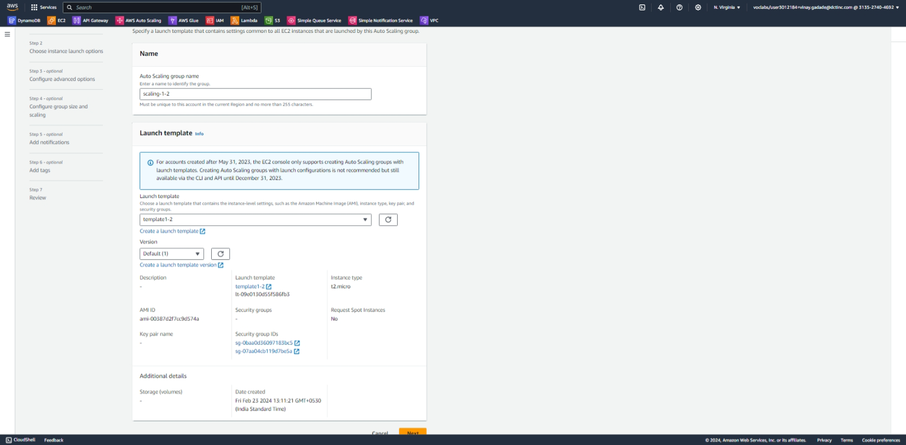

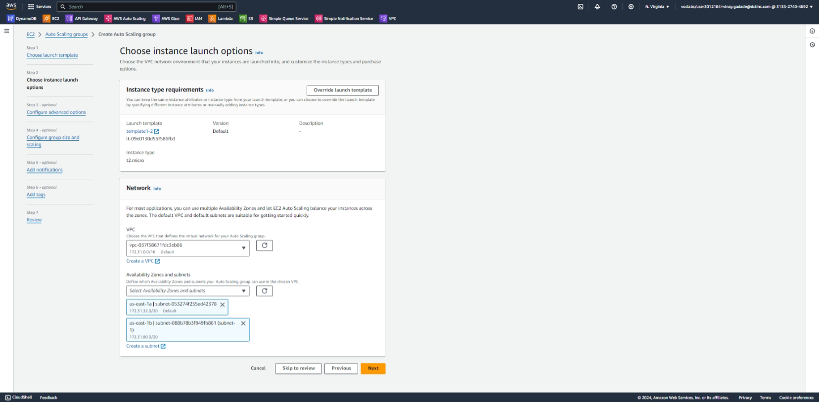

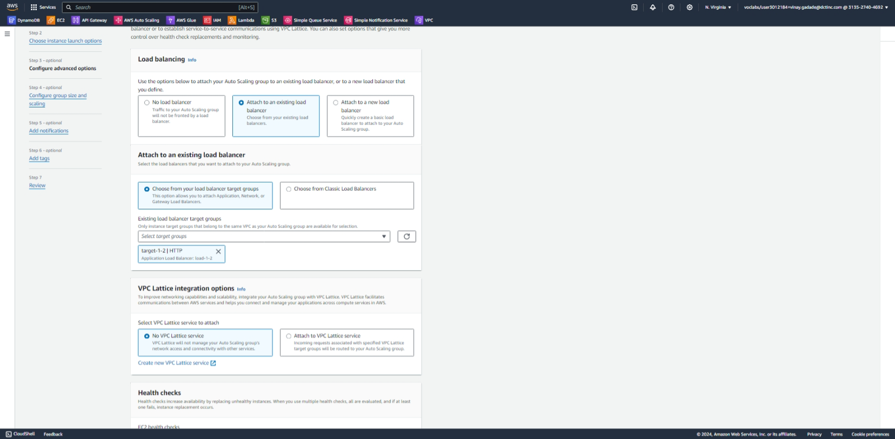

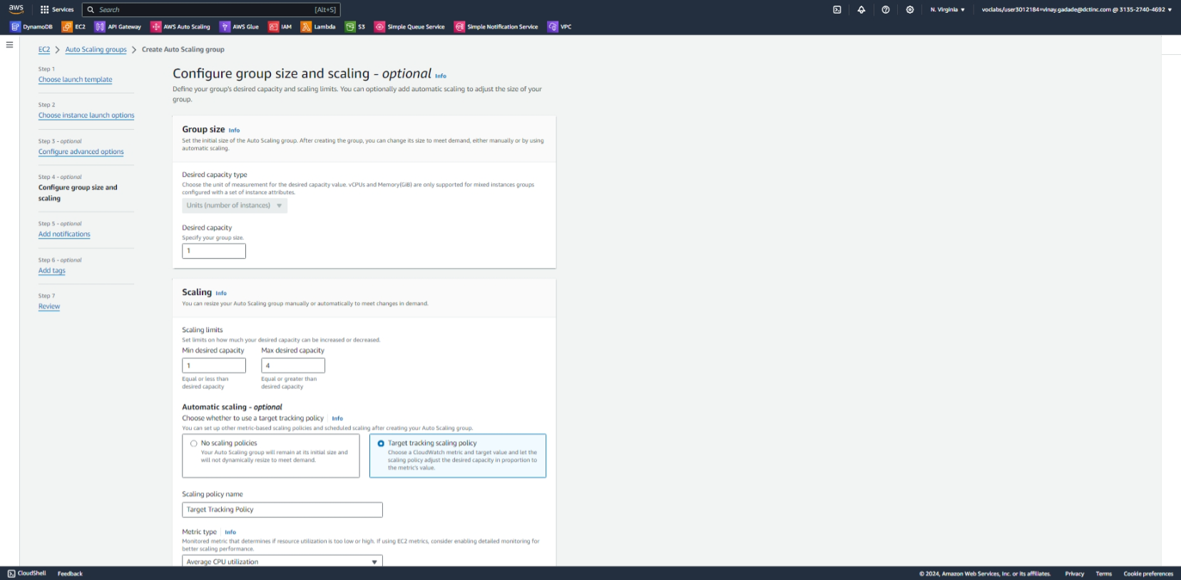

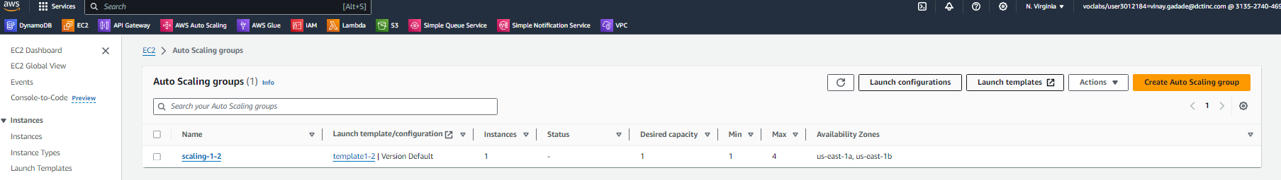

Created unnamd instance

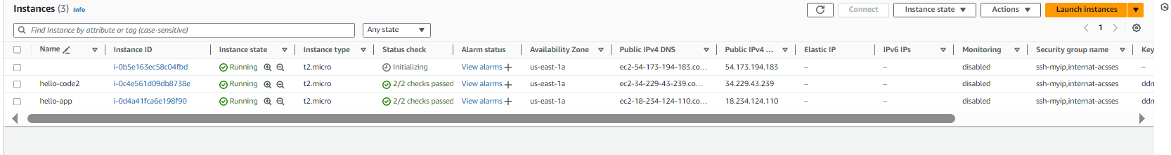

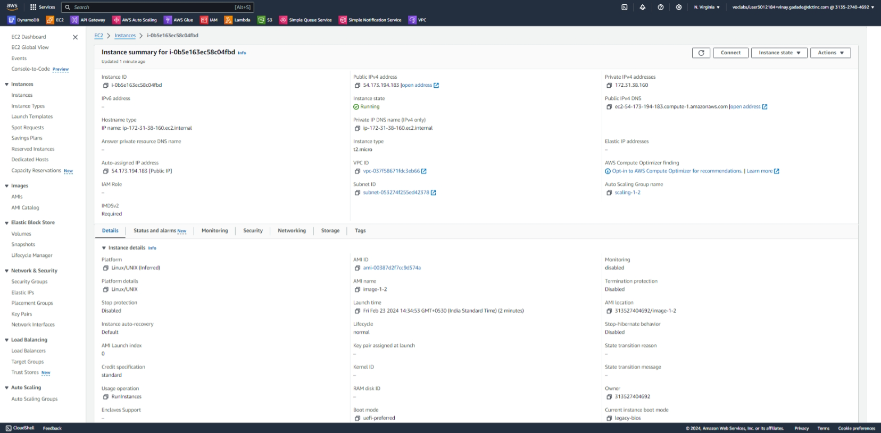

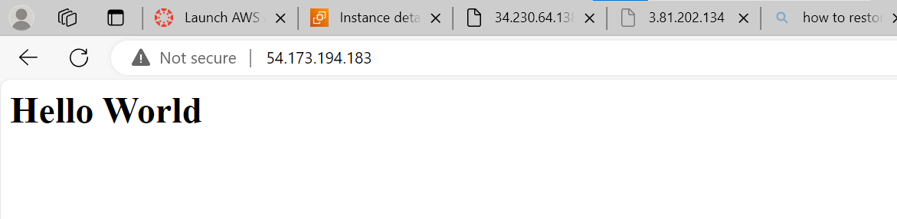

**Part 2: Hosting a Static Portfolio Website on S3**

**Objective**: Learn to host a static website (such as a personal portfolio) on Amazon S3.

1. **Create an S3 Bucket**: Start by creating a new S3 bucket. Configure the bucket for website hosting, which includes setting permissions to make the content publicly accessible.

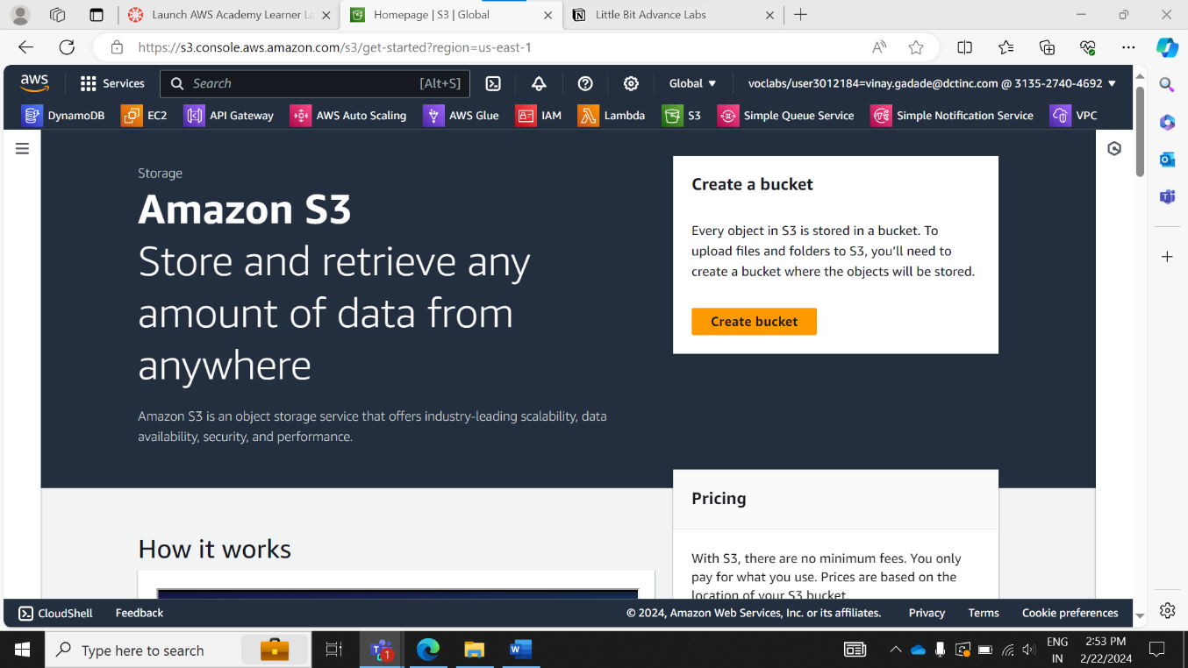

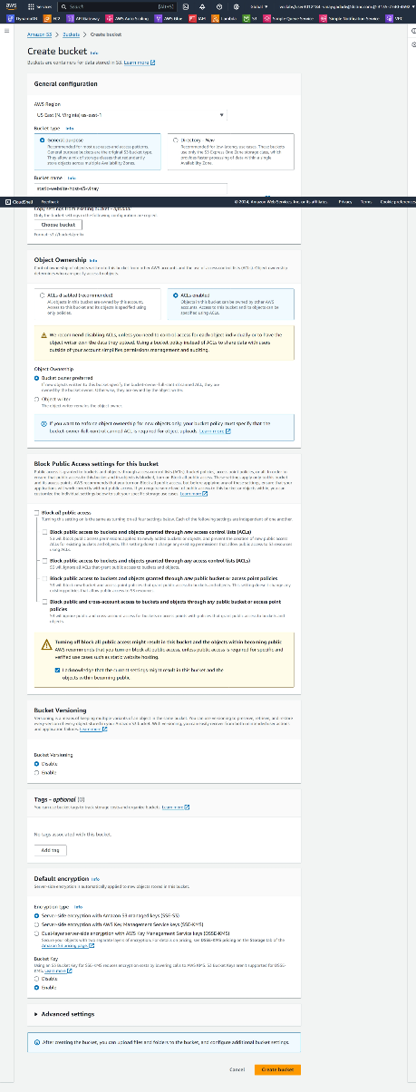

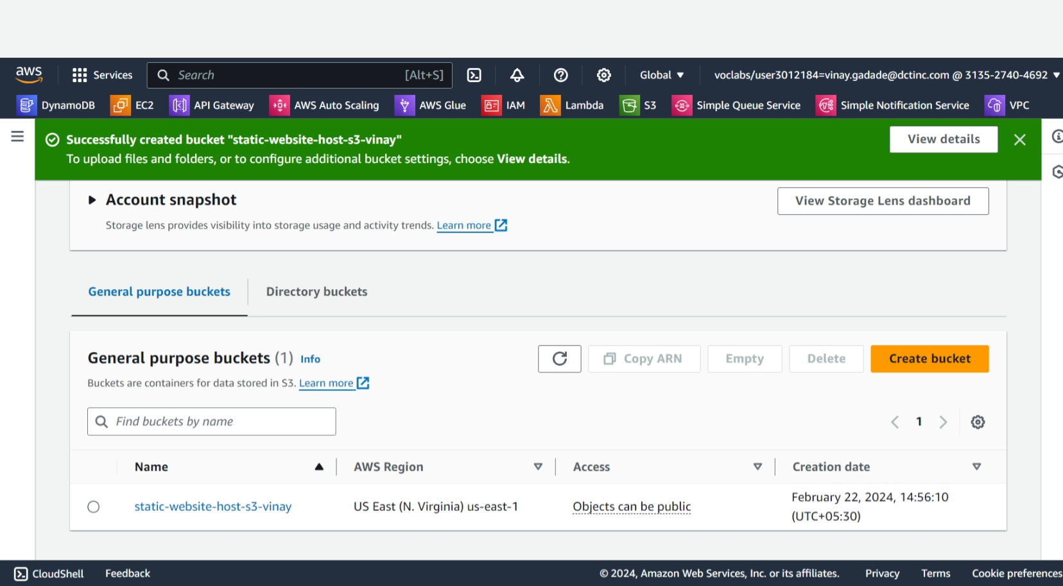

1. **Upload Website Files**: Upload the static files of your portfolio website (HTML, CSS, JavaScript, images) to the S3 bucket.

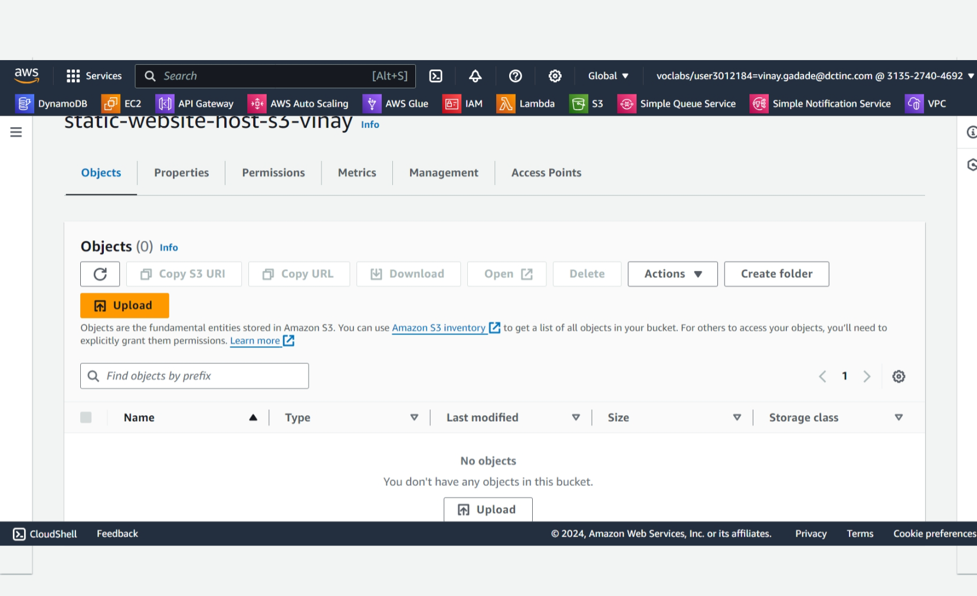

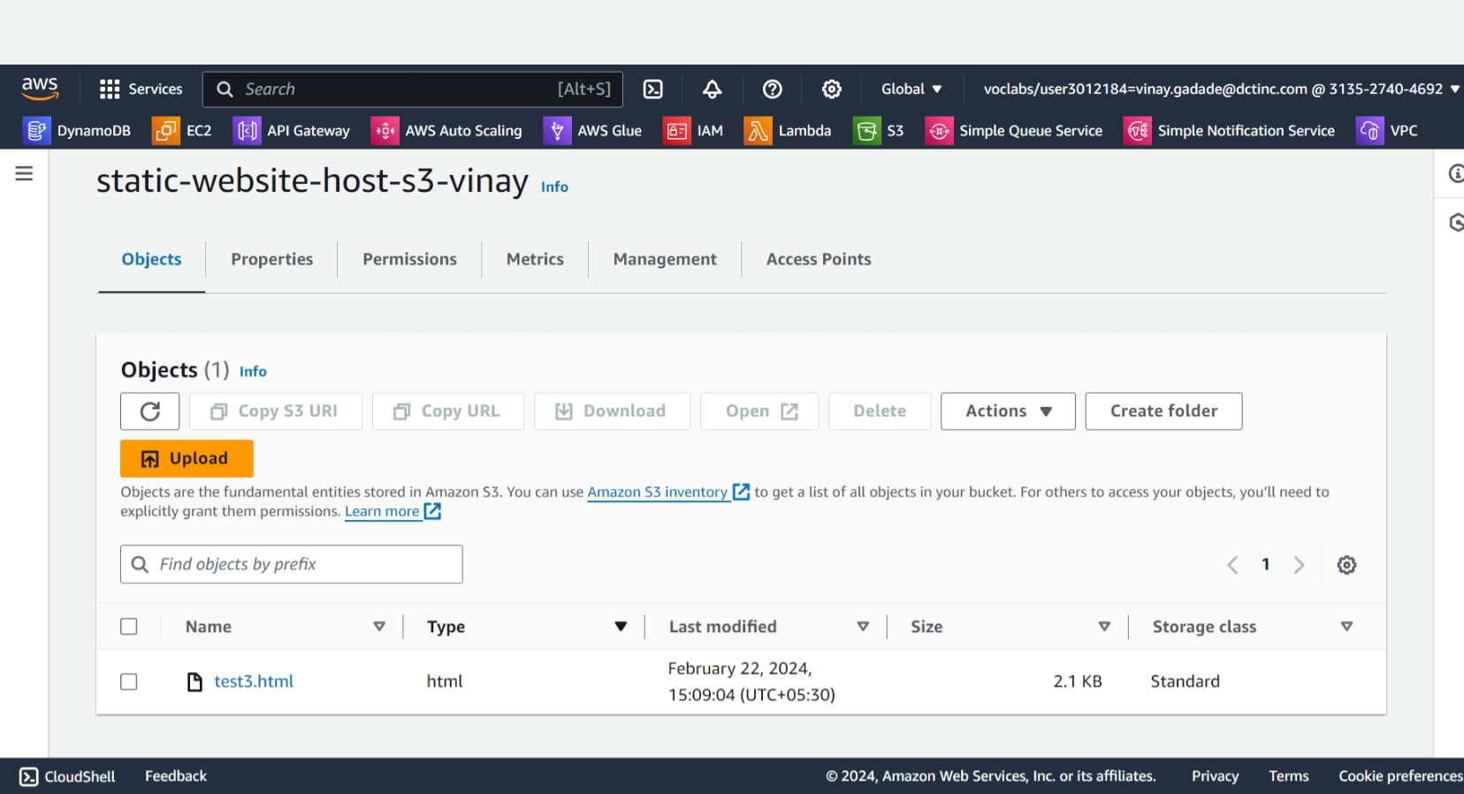

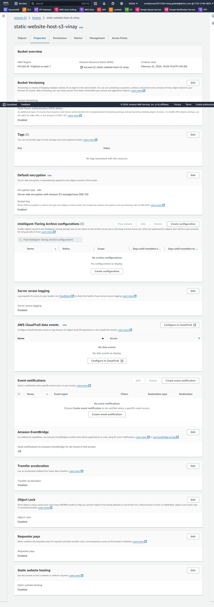

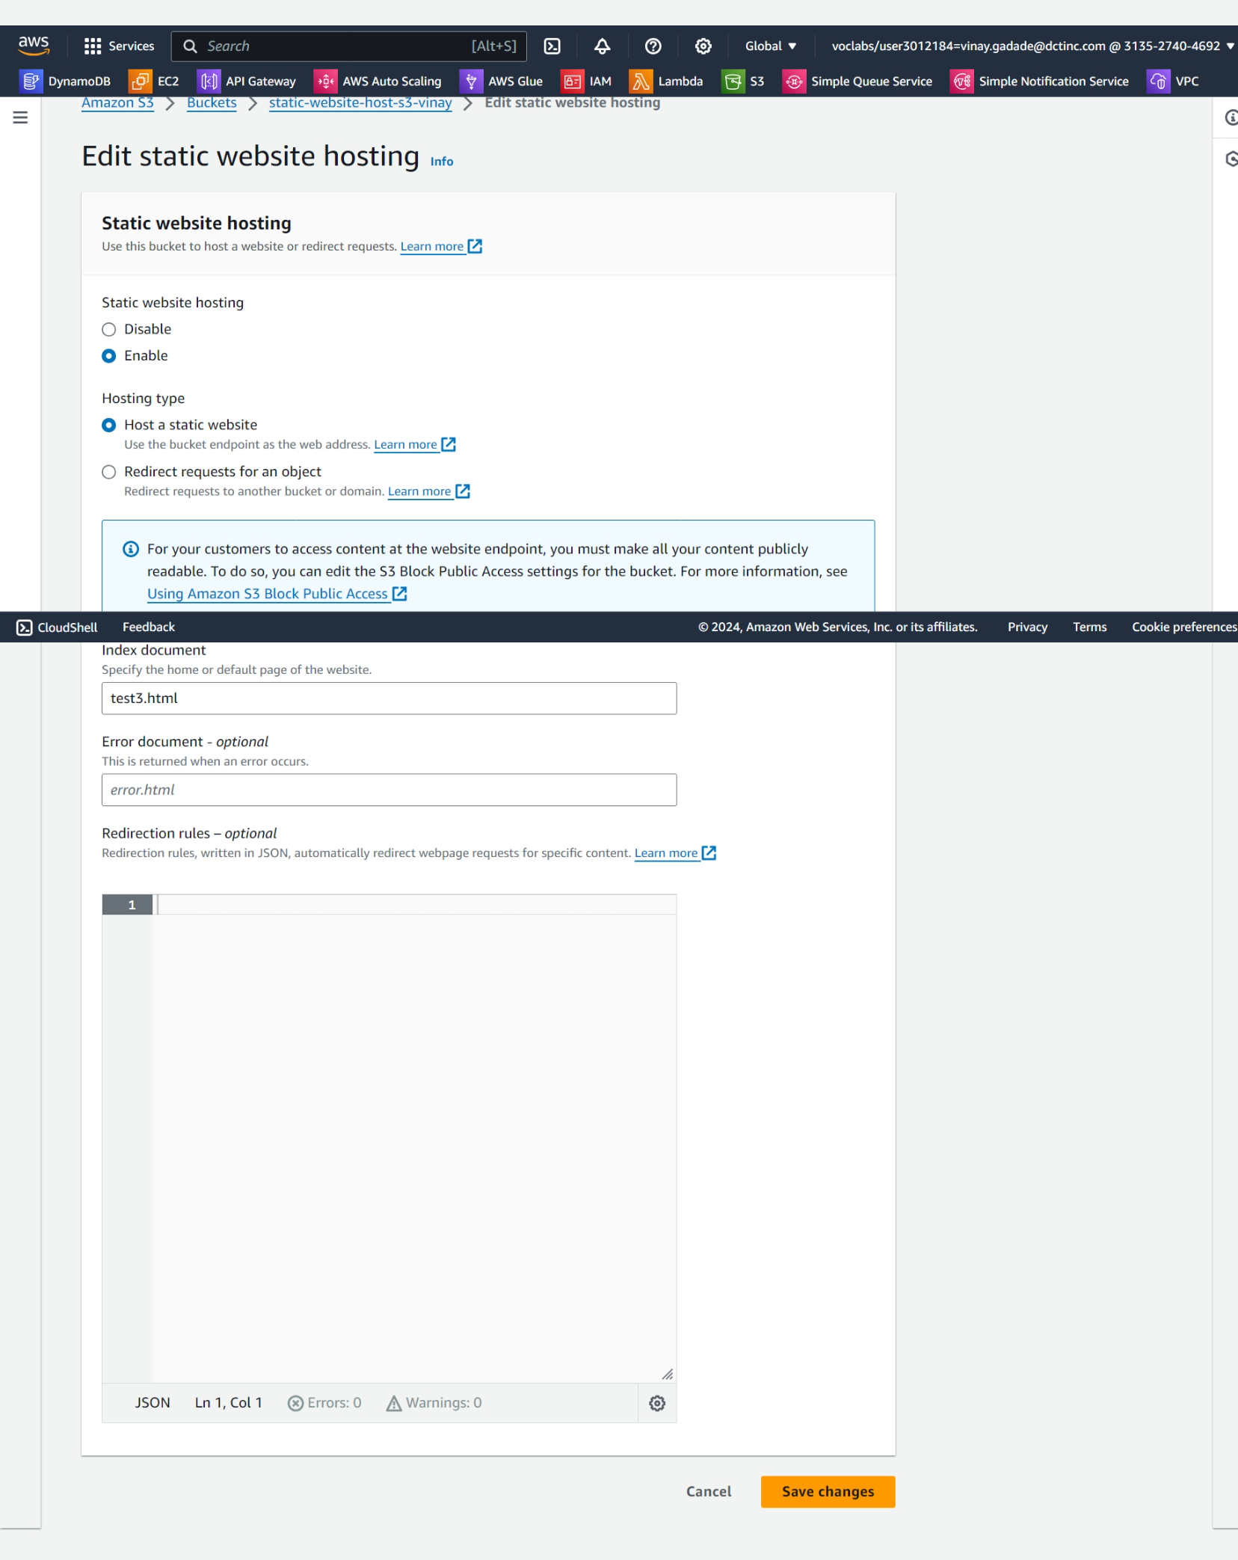

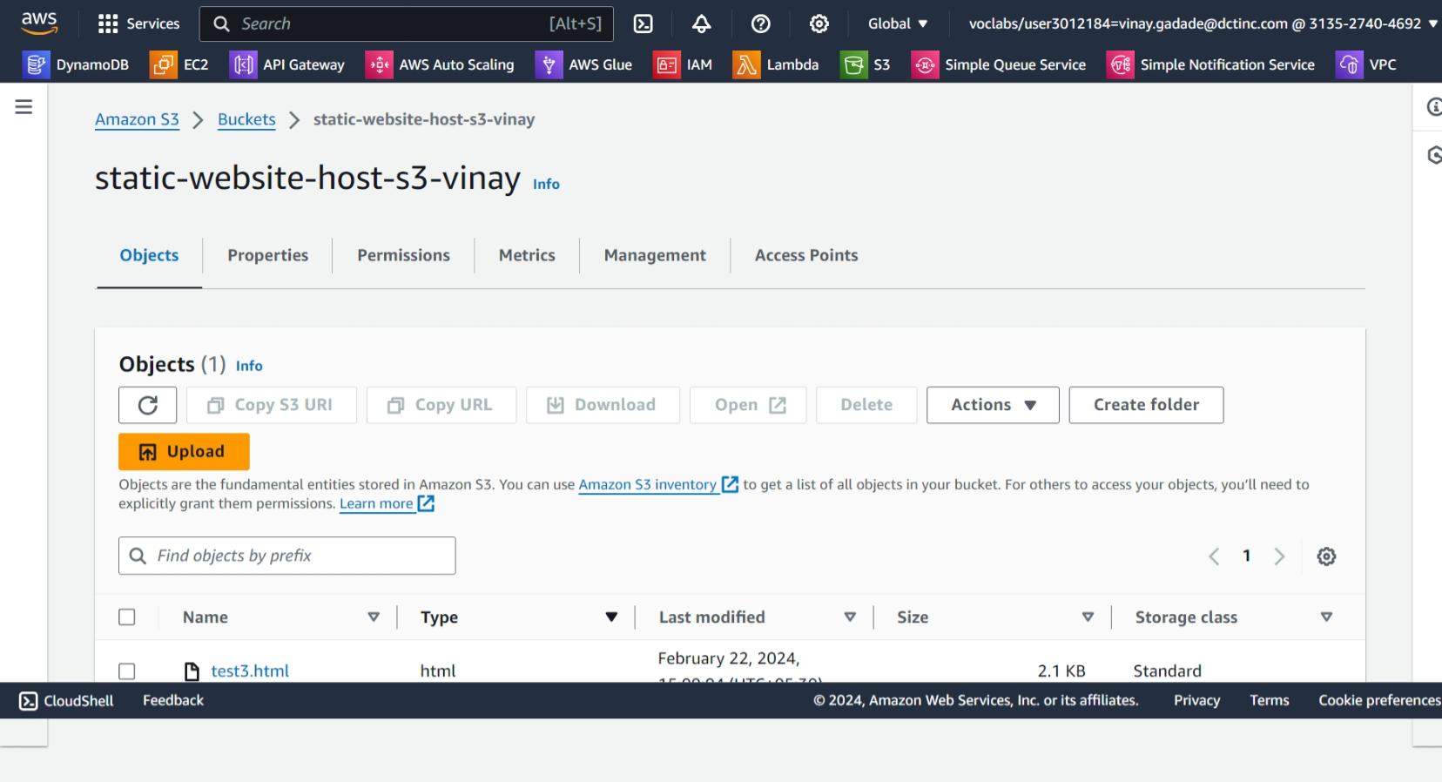

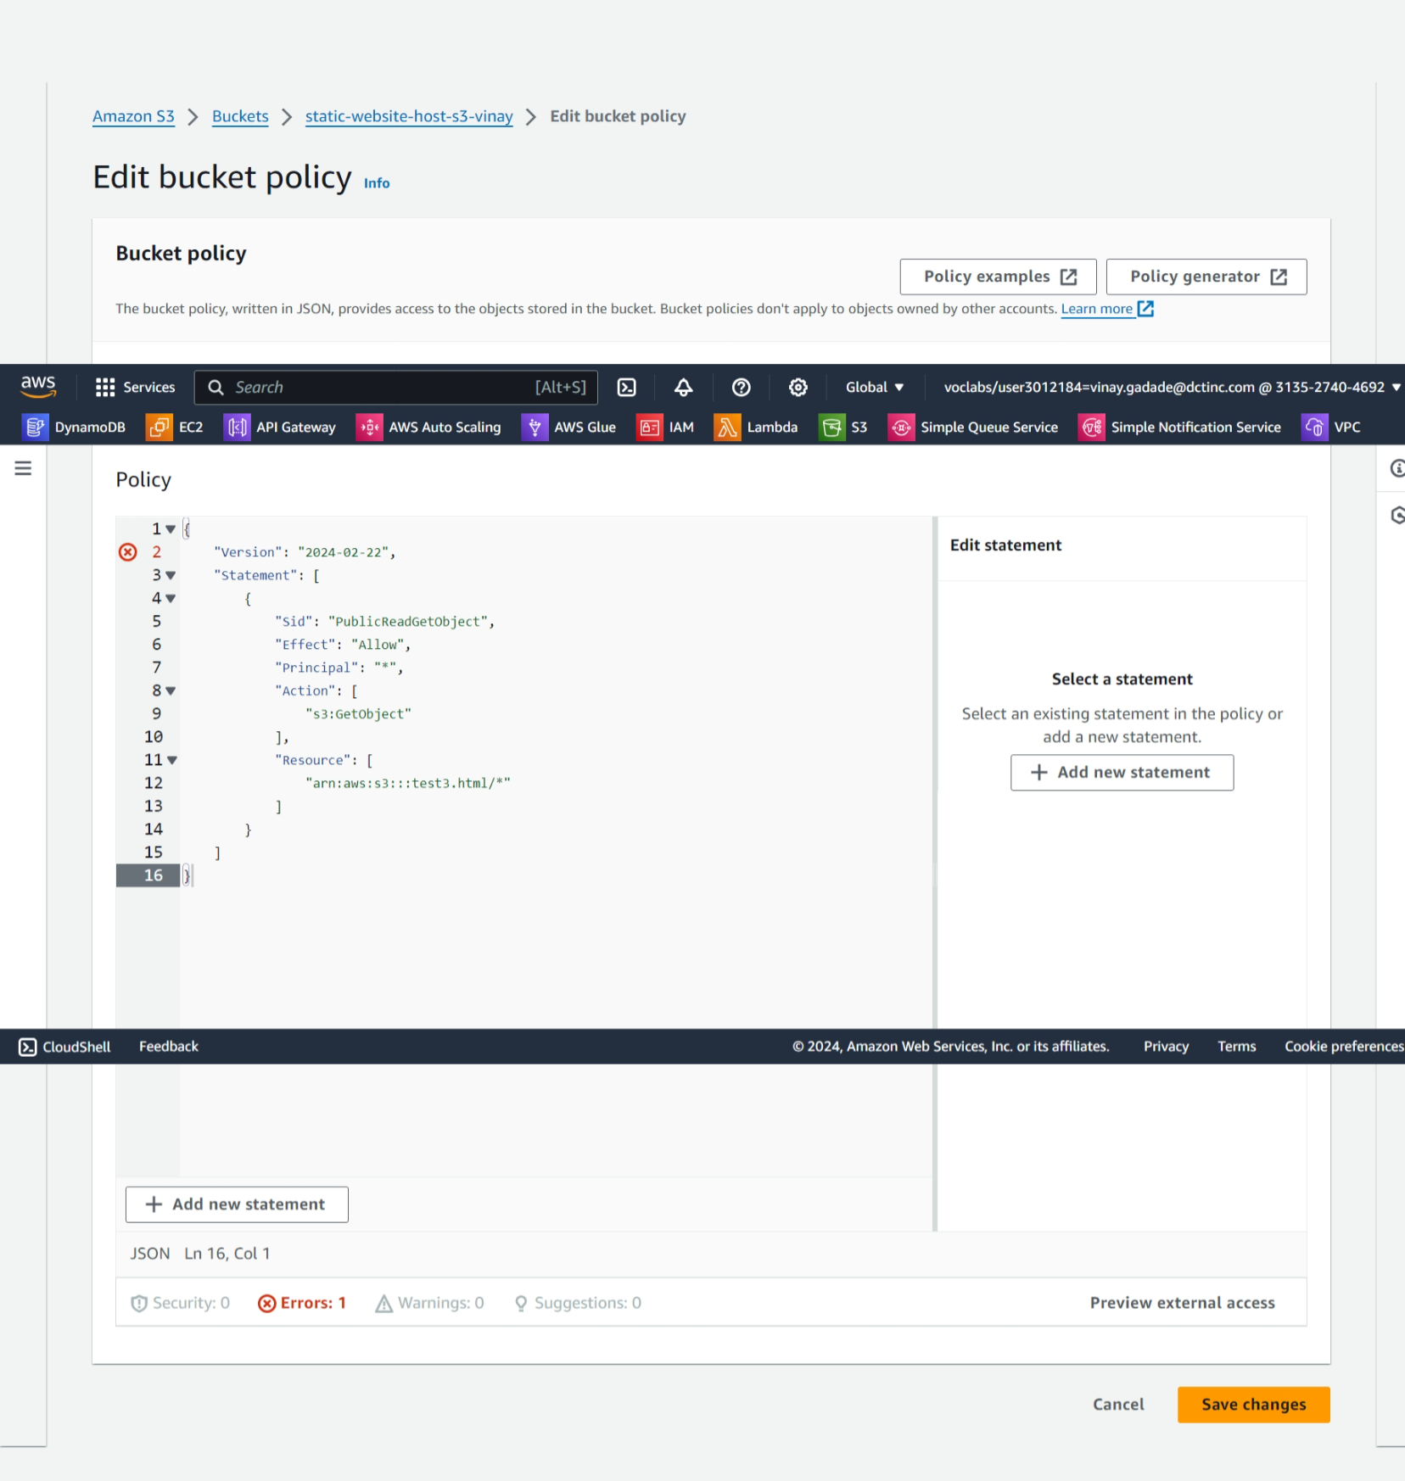

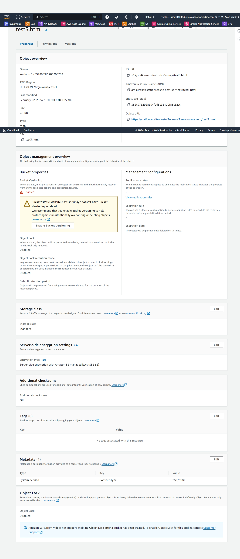

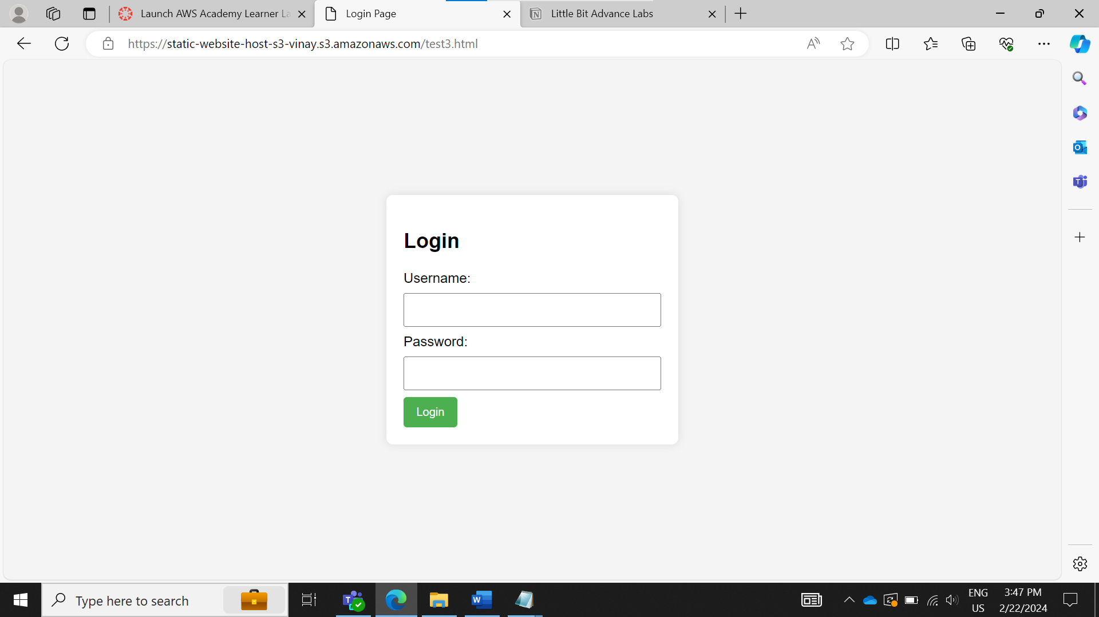

1. Configure DNS: Use Amazon Route 53 or another DNS service to point a domain name to the S3 bucket. This makes the website accessible via a user-friendly URL.

We don’t have a permission to set dns services